Case Study 1: Fiji

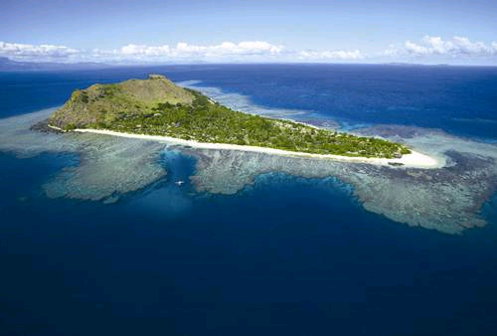

Fiji’s low-lying islands are at the mercy of the rising seas.

Fiji is made up of over 300 islands. Its largest island—Viti Levu—is the center of Fijian politics, economy, and tourism and the source of Fiji’s major crop, the sugarcane. Over 90% of the population, both rural and urban, are considered coastal dwellers. The vast majority of Fiji’s services, infrastructure, agricultural production and social centers are located in coastal regions. Fiji, in particular Viti Levu, faces the multiple challenges of a high population growth rate, intensive urban development, deforestation, pollution as well as increasing exploitation of biological and physical coastal resources, which expose large areas of coast to erosion and inundation.

Climate change threatens to dramatically exacerbate these challenging coastal conditions. Climate changed-induced sea level rise, for example, is expected to precipitate further coastal erosion and inundation. A sea level rise of 59 centimeters, forecasted by the IPCC to occur by 2100, could completely submerge some of Fiji’s lower-lying islands. Viti Levu, with the highest coastal population, is also one of the most vulnerable islands to the effects of climate change. The centre of Viti Levu is mountainous and surrounded by old volcanoes and steep, rocky slopes. This makes relocation particularly difficult for the Fijians who lose their homes and lands due to coastal erosion. Climate change also threatens to increase sea surface temperatures, which may lead to an increase in coral bleaching and a subsequent reduction in sediment production, necessary for maintaining shoreline stability. Changes in storm patterns, such as an increase in the frequency or intensity of tropical cyclones, may cause greater incidence of coastal inundation and erosion Fiji’s economy is largely determined by the success of the sugar and tourism sectors. Climate change and rising sea levels pose a direct threat to agriculture and tourism and will likely worsen economic conditions for Fijians whose standards of living are already considered to be low.

While Fiji is one of the world’s lowest greenhouse gas emitters, it faces some of the worst effects of climate change, among them they threat of complete submersion of its low-lying islands. The threat of such severe consequences of climate change have prompted the Fijian government to take significant measures to mitigate greenhouse-gas emissions. The energy sector is a major source of greenhouse gas emissions in Fiji, with emissions dominated by the transport and energy industries. Fijian mitigation efforts are therefore targeting these industries.

Case Study 2: Bangladesh
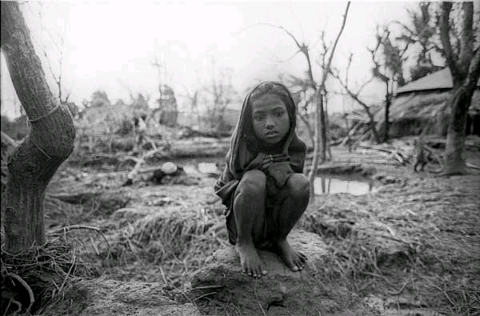
Orphaned girl by the remains of what was her home following Bangladesh’s 199 cyclone.

Threatened by encroaching seas, dwindling water supplies and fiercer storms, Bangladesh suffers some of the worst effects of rising global greenhouse gas emissions. In recent decades, hurricanes in this region have become stronger and continued warming of the Indian Ocean is likely to continue this trend. Monsoon rainfall is also likely to increase, with more intense bursts causing broader, deeper and longer instances of annual flooding and precipitating river erosion. Farmers have already reported changes in the growing seasons. Erratic weather makes it more difficult for them to grow crops on regular schedules. The encroaching sea threatens to submerge a substantial part of the country, helping to storm surges to clear protective embankments.

There is decisive evidence that gender differences in deaths from natural disasters are directly linked to the lack of protection of women’s economic and social rights; indeed women are among the most vulnerable to the effects of climate change. Bangladesh illustrates this point: in its 1991 cyclone disaster, women made up 90% of the 140,000 casualties—many died trying to save their children. This was in part due to women’s poor access to critical resources needed to ensure disaster preparedness, mitigation and rehabilitation. Bangladesh's male-dominated social structure and religious traditions largely restricts the mobility of women—often confining women to the home, , limiting decision-making power and the acquisition of even basic disaster survival skills, such as the ability to swim.

Bangladesh has recently launched a comprehensive action plan to ensure the country's resilience to climate change over the next decade. A major focus of the 2009–2018 plan is to better gauge and monitor the scale and timing of climate change impacts, at regional and national levels. It also focuses on research to develop crop varieties resistant to flooding, drought and salinity and better surveillance systems for new and existing disease risks. This plan does not appear to incorporate any gender analysis.

Case Study 3: Kivalina, Alaska
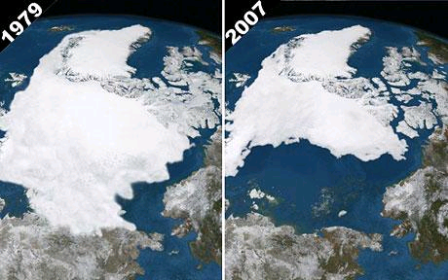
Melting ice in the Arctic.

Kivalina is a traditional Inupiat Eskimo village at the tip of an 8-mile barrier reef located between the Chukchi Sea and Kivalina River. For decades, the Inupiat people have lived a simple life in this tiny Alaskan village, subsisting by hunting for caribou and bearded seal and fishing for salmon and arctic char. For its 400 residents, the weather has always been harsh but life has become even more difficult since the melting of the permafrost that once protected the island from storms. In 2004 and 2005, erosion cut 70-80 feet off the coastline, threatening many of the village's 150 structures, including its only school. In 2006, the U.S. Army Corps of Engineers concluded that the buildings' failures would soon render the community uninhabitable. The community identified the source of the environmental problem to be global warming and proposed to move the village. Yet the relocation cost, estimated between $95-$400 million was prohibitive for a population with a poverty rate twice the national average. On February 26, 2008, the native Inupiat village of Kivalina brought federal lawsuit against nine oil companies (including ExxonMobil Corp.), fourteen power companies and one coal company for damages related to climate change.

Kivalina’s complaint stated that global warming was destroying the village through the melting of Arctic sea ice that formerly protected the village from winter storms and, as such, the village had to relocate or cease to exist. In support of the lawsuit, the complaint cites reports from the U.S. Government Accountability Office and U.S. Army Corps of Engineers that tie erosion in coastal areas of Alaska to global warming. Kivalina is presently seeking monetary damages for the corporations’ contributions to global warming through emissions of large quantities of greenhouse gases. This case differs from other climate lawsuits because it models itself after the lawsuits against large tobacco companies in the 1990s that held cigarette manufacturers liable for hiding the health consequences of smoking. The suit alleges that energy companies conspired to suppress the knowledge of the link between greenhouse gas emissions and global warming, thereby perpetuating doubt and skepticism about the effects of global warming. The economic factors and geographical restrictions specific to this case reveal Kivalina’s limited ability to adapt to the effects of climate change.

Case Study 4: Niger
Niger has been suffering from long term drought in the Sahel, the semi-arid tropical savanna stretching along the southern edge of the Sahara from the Atlantic to the Indian Oceans. Due to even greater drought conditions in the western Sahel, Niger has recently had two food crises in 2005 and 2006. Nomadic pastoralists in the more arid northern regions of Niger, the Muslim Fulani tribe, not only lost much of their herds due to dried up waterholes and dry pastures, but were forced to slaughter their cattle to buy the now more expensive grains for food and fodder. Desperate for survival, many were forced to migrate south with their dwindling herds, causing competition and friction with southern farmers over scarce resources.
Agriculturalists in southern Niger, the Huasa and Ibibio tribes, suffered from both drought and locust attacks, causing the price of food to spike in the entire region. In addition, the rising popularity of cash-cropping and export-market orientated production has resulted in greater vulnerability to climate induced fluctuations in the prices of staple foods. As Lake Chad and its rivers continue to shrink due to diminishing rainfall, fishermen of the Ijo and Ibibio tribes in southern Niger are also feeling the heat.
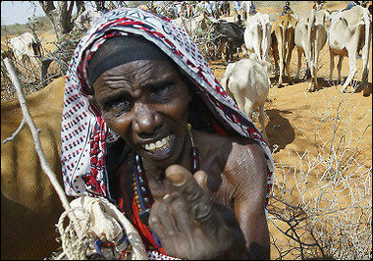
Nomads with their cattle in Niger

Most everyone in Niger is suffering from climate change, resulting in a state of chronic food insecurity. Climate change predictions suggest that the Sahel’s meager 100mm of yearly rainfall will decrease, resulting in longer and more severe droughts. As the Sahara’s desert sands push south internal migration will increase and environmental refugees will become commonplace, resulting in greater regional instability and volatility. Niger’s greenhouse gas emissions are insignificant, but the detrimental effects of climate change on food security and livelihoods are considerable.

Case Study 5: Haiti
Extreme poverty in Haiti is growing even more severe and life-threatening as increased flooding and drought are destroying the homes and livelihoods of the Western Hemisphere’s poorest of the poor. Highly characteristic of climate change in warmer regions, flooding and drought are becoming commonplace. These extremes speed up the process of soil erosion, resulting in more landslides, crop failures and desertification. Farmers are abandoning their once-productive lands, resulting in eroded livelihood and food security.
Having lost the little they once had, many are resorting to such unsustainable industries as charcoal production to eke out a means of survival. Charcoal is used as the primary fuel for cooking in Haiti and is also sold to the Dominican Republic, Haiti’s eastern neighbor on the island of Hispaniola. The border can be clearly seen with Haiti’s desertified mountains to the west, and Dominican Republic’s forests to the east. Already suffering 98% deforestation of its once lush green mountains, Haiti is being stripped of its last trees for charcoal, speeding up the cycle of deforestation, desertification, soil erosion and crop failure.
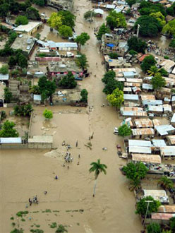
Flood waters in Gonaïves, Haiti after Hurricane Jeanne

While much of Haiti’s climate change is due to unsustainable land use at a local level, the policies of foreign countries have had considerable negative impact on Haiti’s overall ability to sustain its self. Haiti’s own contribution to the greenhouse gasses emissions causing global warming and climate change is virtually 0%, compared to 20% from the United States. In addition, export-oriented agricultural policies in developed countries have contributed to the collapse of Haiti’s agricultural sectors, including rice and corn, forcing many to migrate away from the rural areas to city slums. Haiti’s development prospects have long been thwarted by other countries’ policies, but now they are becoming even bleaker in the face of flooding, drought, soil erosion and desertification.

Case Study 6: Seychelles
Seychelles, an island nation located off the coast of East Africa in the Indian Ocean, is heavily dependent on its coral reefs for fishing and tourism. For many island nations in the Pacific and Indian Oceans, coral reefs are at the center of their livelihoods and cultures. Coral reefs have continuously and increasingly provided a wide range of goods and services, as well as playing a vital role as natural breakwaters, minimizing wave impacts during storms and cyclones. Coral reefs are biologically diverse but fragile ecosystems, highly vulnerable to the effects of global warming.
Global warming caused by increased levels of greenhouse gasses presents major hazards to coral reef ecosystems, such as rising ocean temperatures and increasing acidification due to rising levels of dissolved carbon dioxide. Most marine organisms live within narrow temperature regimes, and even short-term extreme temperature increases can have dramatic impacts. As ocean temperatures rise, reef building corals stressed by high temperatures tend to eject their symbiotic algae and die, resulting in coral bleaching. In addition, as carbon dioxide levels in the atmosphere increase, so does dissolved carbon dioxide in ocean waters. This, in turn, results in increased acidification, making it harder for coral and other calcifying organisms like crustaceans and mollusks to absorb the calcium they need to build their shells. Coral reefs play a vital role in marine life, providing spawning, nursing, feeding and refuge areas for reef and ocean fish. The collapse of coral reefs is thus also causing ocean fish stocks to sink.
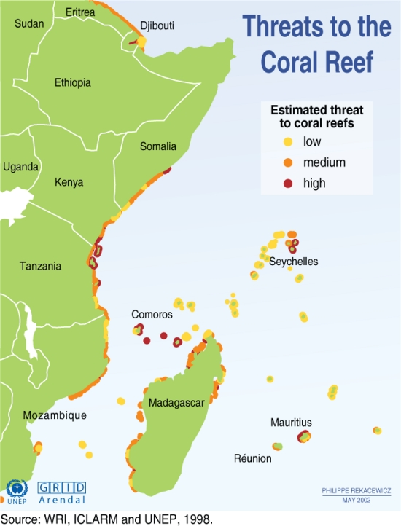
While the Seychelles, like most island nations, has contributed little to global warming, they will suffer from the loss of their natural resources. But the consequences of dying coral reefs will also be felt across the globe as ocean fish stocks plummet and it becomes harder for them to replenish themselves.

