Assisting the World’s Transition to a Sustainable Energy Future

L. Staudt, Centre for Renewable Energy, Dundalk Institute of Technology, Ireland

Abstract

This paper seeks to create a vision for a sustainable energy future based on Bahá’í teachings. It looks at some of the practical steps and processes required on the way to achieving that vision. This paper will discuss the nature of the physical world, the principle of sustainability generally and in an energy sense, the present energy situation, and energy options for the planet.

Background

Renewable energy has become quite topical, and it is gradually being realised that our energy future, if it is to be sustainable, lies in that direction. We have been blessed with fossil fuel resources which have greatly aided the material development of the planet. However these resources are limited and we must prepare for a future without them. Figure 1 shows the development of energy use over time as a percentage of total energy consumption. For example in 1900 3% of our energy came from oil, 36% came from biomass, and 61% came from coal, totalling 100%. It shows how we have moved from renewable energy (biomass, mostly wood) to fossil fuels (first coal, then oil, then the present move to natural gas), and appear to be moving back to a mix of renewable energy technologies.

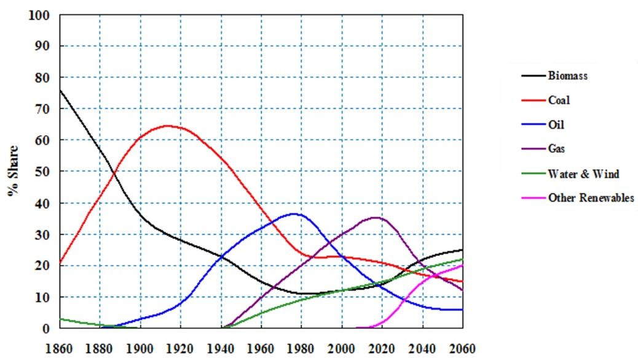

Figure 1 - World Market Share of Energy (1860-2060)

Fossil fuel production (and consumption), taken over a long period of time, looks something like Figure 2. We are living during the brief period during which humanity has access to fossil fuels. The figure shows graphically the obvious fact that there is a finite amount of fossil fuel (coal, oil and gas) to be found, and so we need to come up with a plan for a sustainable energy future. This is no easy task. As has been frankly stated by the Danish Society of Engineers: “The trouble is that no realistic technological, economic and political strategies for the warding off of the impacts of a decline in conventional oil supply are in sight.”

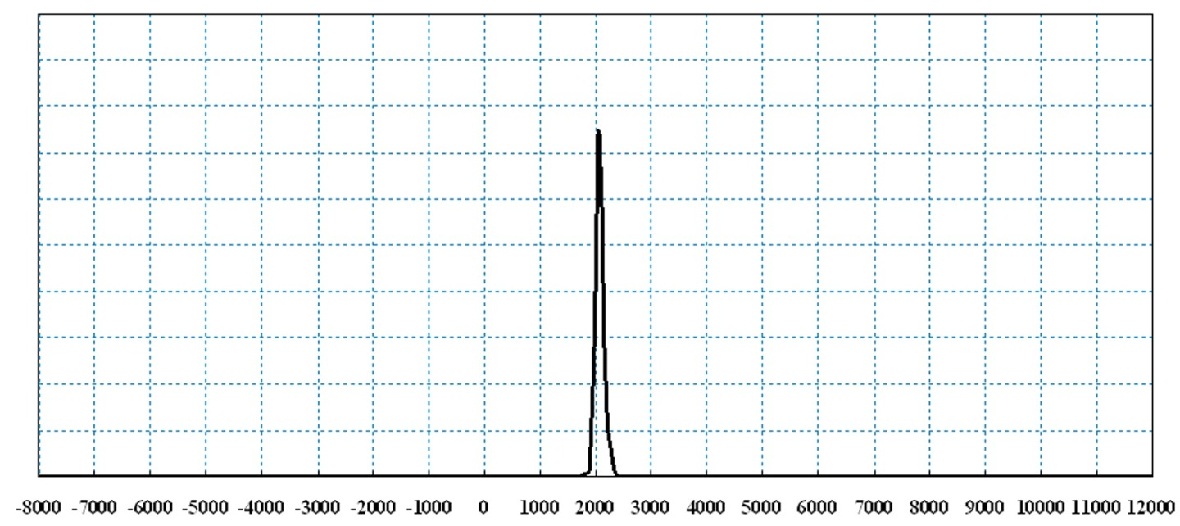

Figure 2 - Fossil fuel consumption (8000BC to 12000AD)

The Principle of Sustainability

Sustainability is often defined as “meeting the needs of the present without compromising the ability of future generations to meet their needs.” Sustainability is increasingly becoming the touchstone or criterion by which all human activities are being measured. Although society is at present clearly unsustainable in many respects, it is taking its first steps down this road, and the very first step is the realisation by all members of the human race of the need for sustainability. Therefore we should feel encouraged to hear this word being used as often as it is.

In an energy sense, sustainability has quite a concrete meaning, and points society in the clear direction of renewable energy. Some years ago renewable energy was not taken as a serious option and the notion of life after fossil fuels was not properly considered in the hope that the “market” would come up with something, probably making use of nuclear fission or fusion. Herman Daly described the energy policy of the past as follows:

“Recent growth rates of population and per capita energy use… are projected up to some arbitrary, round-numbered date. Whatever technologies are required to produce the projected amount are automatically accepted, along with their social implications, and no thought is given to how long the system can last once the projected levels are attained…
“This approach is unworthy of any organism with a central nervous system, much less a cerebral cortex. To those of us who also have souls it is almost incomprehensible in its inversion of ends and means.”

The implication of the last sentence is that we are failing to realise that our (energy-related) activities must work within a context of knowledge of our earthly purpose, and not simply serve mysterious but unquestionably valid market forces. Indeed, we could say that at present we (the human race) don’t even know the “ends” our energy activities on earth serve, and we are fairly mindlessly making use of the energy “means” at our disposal. These are characteristics of an adolescent society.

It is imperative to realise that humanity has rapidly moved from a society that was primarily lived at the local level and in a sustainable manner to one of contemporary excess. In the past, sustainability was not such an important issue, since in general human society did not have the technology or the scale to live unsustainably. With the discoveries of recent times, this is no longer the case. We have moved into a situation where our powers have multiplied, and without much thought we have simply raced forward to use these powers. We are clearly in an adolescent phase, and are only beginning to think about the responsibilities of adulthood as a society. The good news is that we can be confident that adulthood will follow adolescence. Knowledge of purpose combined with an increasing appreciation of the wonder and complexity of the natural world will result in the human race “living lightly” upon the earth.

There is an intriguing vision of a mature society in the writings of the Bahá’í Faith, which embodies the principle of sustainability:

"National rivalries, hatreds and intrigues will cease, and racial animosity and prejudice will be replaced by racial amity, understanding and co-operation. The causes of religious strife will be permanently removed, economic barriers and restrictions will be completely abolished, and the inordinate distinction between classes will be obliterated. Destitution on the one hand, and gross accumulation of ownership on the other, will disappear. The enormous energy dissipated and wasted on war, whether economic or political, will be consecrated to such ends as will extend the range of human inventions and technical development, to the increase of the productivity of mankind, to the extermination of disease, to the extension of scientific research, to the raising of the standard of physical health, to the sharpening and refinement of the human brain, to the exploitation of the unused and unsuspected resources of the planet, to the prolongation of human life, and to the furtherance of any other agency that can stimulate the intellectual, the moral, and spiritual life of the entire human race.”

The quotation goes on to say that our society will make use of “all the available sources of energy on the surface of the planet.” The implications of this short phrase are:

- There will be no energy panacea. If “all the available sources” are being used, then there won’t be any single discovery (e.g. cold fusion) which will take care of all of our energy needs.
- Renewable energy, in its various forms, will provide our energy needs.

Renewable Energy and the Future – a Vision

Renewable energy is essentially “all the available sources of energy on the surface of the planet.” The sun’s rays impact the earth, resulting in direct heating and photosynthesis. The resulting temperature differences result in the wind, which in turn results in the waves. The tides originate from the moon’s gravitation pull on the oceans of the world. Geothermal energy originates in the earth’s crust, and we tap it at the earth’s surface. All can be used to create useful energy, and all of our energy needs can and will be met from renewables – the real question is how to make the transition from where we are now to our renewable energy future.

A word should be said about our “needs”. Energy consumption has increased by an order of magnitude over the last half century. Quality of life has not increased by an order of magnitude. With advances in energy efficiency and energy conservation techniques, the entire planet can live very comfortably at a reduced and sustainable level of energy consumption. World population will have a major effect on energy needs, as will a reduction in the extremes of poverty and wealth. The energy needs of a society whose focus is spiritual development will probably require less energy per capita.

A word should also be said about nuclear energy. Nuclear energy presently provides about six percent of the world’s energy. Nuclear fission (the only commercial nuclear technology) consumes uranium to generate power. According to the European Nuclear Society, with present economic reserves “all 436 world-wide operating nuclear power plants can be supplied for several decades.” The contribution that nuclear energy can presently make is therefore significant but limited. Although there are some promising possibilities for future nuclear technology, we cannot plan for nuclear energy to ultimately play a role in a sustainable energy future, though this may change. However all sources of energy, including nuclear fission, will be necessary during our transition to energy sustainability.

The major advantages of renewable energy include:
- Little or no pollution or greenhouse gases (i.e. environmental sustainability)
- Available now and forever (i.e. supply sustainability)
- No increasing fuel costs (price stability)
- Low concentrations available world wide (unlike e.g. present oil concentration in the Middle East, thus improving supply security)
- Potential for development of indigenous energy industry, with associated jobs (since renewable energy needn’t be on the scale of fossil energy technology, and thus the exclusive domain of countries with heavy manufacturing capability)

The challenges for this transition to a sustainable energy future include:
- The cost of renewable energy is generally higher than fossil fuels
- Renewable energy comes in relatively low concentrations
- A large capital investment required globally to make the transition
- New infrastructure (e.g. transmission lines) is required
- Limited time to make the transition (see below)
- Insufficient global energy governance to effectively manage the transition

It is possible to make the transition to a sustainably-powered society, although it will be more easily accomplished in some countries than others. To take Ireland as an example, about 90% of Irish energy is imported, compared with the EU average of about 50%. Ireland is completely exposed to volatile oil and gas markets. At present about 4% of Ireland’s energy comes from renewable sources. This is made up mostly of hydro and wind electricity generation, which supplies about 12% of Irish electricity needs.

Ireland is blessed with a very large renewable energy supply. An estimate of the potential for wind energy alone is given in an ESB International study where it is pointed out that “wind power could generate around 345TWh per annum, or around 19 times the current electricity production of the ESB system.” This report did not consider offshore wind potential, which is also huge. The report also indicates very impressive potential for bioenergy and wave power in Ireland.

The cost of wind power has declined rapidly since the beginning of its commercial development in the early 1980s. In wind-blown Ireland the cost of electricity from the wind is now the same as fossil-fuel “brown” electricity. When value is given to pollution (e.g. through carbon taxes), wind turbines at lower wind speed sites will also become viable. It is now possible to supply Irish electricity needs, now and forever, with only a small increase in electricity prices.

It is also necessary to consider the dynamics of the transition to energy sustainability. The capital investment required to make the transition is substantial, and large capital projects take time to implement. With this in mind, a computer model was created in order to investigate the implications for the Irish economy of the transition to energy sustainability. The general conclusion was that substantial capital investment in renewable energy infrastructure was needed immediately for an orderly transition to sustainable energy. These results can generally be extended to the global economy. If we wait until the cost of fossil energy rises to a point where renewable energy “makes economic sense” it is too late, since we will not be able to afford the capital investment at that point due to the high cost of energy. In other words market economics do not call for this transition soon enough – what is required is a managed transition, with local, national and international government involvement. This is an argument in favour of global energy governance, which presently doesn’t exist.

However, there is historical precedent for a relatively rapid change in the energy supply industry. The report “State of the World” points out:

“The closing decades of the nineteenth century were a fertile period in the history of technology, as inventors applied novel scientific advances to a range of new devices. The incandescent light bulb, electric dynamo, and internal combustion engine were invented in the late 1800s but had relatively little effect on industry or daily life as the century ended. As they came into widespread use in later decades, however, it became clear in retrospect that the technological foundation for the transition was largely in place by 1900.”

Very few in the late 1800s could have predicted the massive change in the energy economy, primarily one moving from coal to oil. The technology for the change was essentially available at that time, but it was only subsequently used on a large scale. Another interesting energy transition is going to occur in this century, using technology developed in the late 1900s. Once again it will be a massive, society-changing transition.

It is beginning already. For example, in 2008 more wind power generating capacity was installed in Europe than any other type of generating plant – more than gas, oil, coal or nuclear power. Ireland has a national goal of producing 40% of national electricity needs from renewables by 2020, and is presently at 12% and on track to reach that goal. We conclude that a renewable energy-based future is desirable, possible and inevitable.

Assisting the World’s Transition to a Sustainable Energy Future

With this clear vision of the direction in which world energy policy must lead, the question of “How do I assist the world’s transition to energy sustainability?” needs to be asked. Bahá’u’lláh says: “Be anxiously concerned with the needs of the age ye live in, and center your deliberations on its exigencies and requirements.” Given that the world energy industry is a multi-trillion dollar industry which will make a transition from fossil fuels to renewable energy over the coming century, in general terms there are any number of opportunities within the energy industry where Bahá’ís can contribute, and this is discussed below.

However, outside of the energy industry itself Bahá’ís can also assist this transition. We can implement energy conservation and domestic renewable energy solutions in our lives, even when they are not “economic” in the conventional sense of the word. For example, if a local electricity supplier offers a “green” tariff, which offers a relatively expensive green electricity option, signing up for this option will encourage renewable energy generation, reduce greenhouse gas emissions, and incentivize your own energy conservation. There are many other suggestions to be found at www.climatecrisis.org. In their children’s classes, Bahá’ís can stress the importance of sustainable energy as appropriate. Generally, all Bahá’í activities contribute in the long run toward a sustainable energy future for the planet, in that they encourage (both individually and collectively) a spiritually-focused, moderate lifestyle which will have relatively low per-capita energy needs.

The Bahá’í writings envisage:

“A world federal system, ruling the whole earth and exercising unchallengeable authority over its unimaginably vast resources, blending and embodying the ideals of both the East and the West, liberated from the curse of war and its miseries, and bent on the exploitation of all the available sources of energy on the surface of the planet, a system in which Force is made the servant of Justice, whose life is sustained by its universal recognition of one God and by its allegiance to one common Revelation -- such is the goal towards which humanity, impelled by the unifying forces of life, is moving."

With this vision, we offer a few examples of how Bahá’ís involved in the energy industry can facilitate the transition to a sustainable energy future. The possibilities are endless.

- Helping develop world energy policy – At the present time, society is institutionally unprepared to conduct many badly-needed world-level activities. For example we are a long way from developing and implementing world energy policy “exercising unchallengeable authority over its unimaginably vast (energy) resources.” Recently several members of the Bahá’í-inspired International Environment Forum wrote and presented a paper at an international conference in Italy entitled “Global Energy Policy: Transforming Governance for the Transition to a Sustainable Energy Future.” It gently points out the need for authoritative world energy policy.
- Helping develop an ethical green energy industry – the author is aware of a number of Bahá’ís who are actively involved in the renewable energy and energy conservation industries, struggling to make and/or distribute products that will help bring about a sustainable energy future. For example, Arizona Bahá’í David Calley is the founder and chairman of the board of Southwest Windpower, a world-leading small wind turbine manufacturer.
- Conducting academic energy research and educating a new generation of energy engineers and scientists (the work of the present author)
- Helping facilitate the development of utility-scale renewable energy in a way that minimizes environmental harm and involves stakeholders in a consultative process. Anne Gillette, a Bahá’í working with the California Public Utility Commission, is helping get agreement between utility companies and environmental groups for transmission lines from new renewable energy facilities.
- Working to develop community-based sustainable energy projects – the author is aware of a number of social and economic development projects which make use of sustainable energy practices

Our efforts are guided by a much bigger framework and vision than most of our friends working in this field. We can see how sustainable energy practice is one of the many puzzle pieces needed to facilitate an “ever-advancing civilisation”. The phrase “Think globally – Act locally” is particularly applicable to the Bahá’í community.

Conclusion

Our primary function as human beings on this beautiful planet is spiritual development. We need to work to optimise the conditions of society for this function, and advance civilisation sustainably such that future generations can also effectively make their pilgrimage through this life.

One important part of this future society will be a sustainable energy system, which it seems will be based on renewable energy. It is quite evident that we are at the beginning of a major transition from fossil fuels to renewable energy – a transition that will take place at an increasing pace, and largely take place during this century. This transition is desirable, possible, and appears inevitable, and is an exciting area to which Bahá’ís can contribute.

With this vision we can all play our part as responsible consumers of energy, and those of us in the energy industry can play our part by facilitating the responsible transition from the present fossil fuel energy system to one based on renewable energy.

References

ESB stands for Electricity Supply Board. It is the primary electricity supplier in Ireland.
Society of Danish Engineers and the Danish Board of Technology (2004)
World Commission on Environment and Development, Our Common Future (Oxford University Press, 1987), p.8
H. Daly, On Thinking About Future Energy Requirements (Louisiana State University, 1976)
Shoghi Effendi, The World Order of Bahá’u’lláh (Bahá’í Publishing Trust, 1938), p.204
European Nuclear Society, www.euronuclear.org, see Glossary under Uranium Resources
ESB International and ETSU, Total Renewable Energy Resource in Ireland, 1997
Staudt, L., Ireland’s Energy Outlook, Engineer’s Ireland Annual Conference, 2007
Crane, D. and Staudt, L., Simulating a Sustainable Ireland, Before the Wells Run Dry, Feasta, 2003
Brown, Flavin et al, State of the World (W. Norton and Company, 1999)
Bahá’u’lláh , Gleanings from the Writings of Bahá’u’lláh, p. 213
Shoghi Effendi, The World Order of Bahá'u'lláh, p.204
Karlsson, S., Jollands, N., and Staudt, L., Global Energy Policy: Transforming Governance for the Transition to a Sustainable Energy Future, 2009 International Energy Workshop, Venice
See www.windenergy.com

